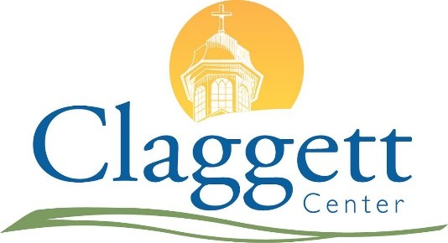**2023 Event Priority Reservation Form**Episcopal Dioceses of Maryland & Washington

***Forms are due by COB September 15, 2021.****\*\* A separate form is required for EACH event. \*\**

**Group Name:** Click or tap here to enter text.

**Name or Type of Event:** Click or tap here to enter text.

**Event Contact Name:** Click or tap here to enter text.

**Address:** Click or tap here to enter text.

**Telephone Number:** Click or tap here to enter text. **Email:** Click or tap here to enter text.

**Secondary / Billing Contact Name:**

**Address:** Click or tap here to enter text.

**Telephone Number:** Click or tap here to enter text. **Email:** Click or tap here to enter text.

**Diocesan Affiliation:** Choose an item.

**Preferred Dates:** *List your top three choices for* ***2023*** *event dates.**Please complete all three options.   
If you wish to book an event prior to 2023, please contact Kim Wyand (301.874.5147 ext. 4298) directly.*

**1st CHOICE:** Arrival: Click or tap to enter a date. Departure: Click or tap to enter a date.

**2nd CHOICE:** Arrival: Click or tap to enter a date. Departure: Click or tap to enter a date.

**3rd CHOICE:** Arrival: Click or tap to enter a date. Departure: Click or tap to enter a date.

**Check in Time:** Click or tap here to enter text. **Check out Time:** Click or tap here to enter text.  
*Lodging room check out is 10 a.m. on departure date. Most meetings spaces are available until later in the day.*

**Lodging Request:** *Check all that apply.*

**Christiane Inn** (42 singles, 18 doubles)  
 # of Singles Click or tap here to enter text.  
 # of Doubles Click or tap here to enter text.

**Doll Cottage** (11 bedrooms, 22 beds)

**East Cottage** (4 bedrooms, 10 beds)

**Farmhouse Cottage** (4 bedrooms, 10 beds)

**Powell Hall** (Dorms, 99 beds)

**Shalom Cottage** (2 bedrooms, 3 beds)

*\*North Cottage is not available at this time.*

**Estimated Number of Guests:** Click or tap here to enter text.

How many of your guests are day participants only? Click or tap here to enter text.

**Meeting Room Request:** *Occupancy numbers are shown in parenthesis based on auditorium style seating. Meeting spaces are assigned proportionally based on group size. Additional meeting space may incur fees.*

Monocacy (50)

Potomac (50)

Shenandoah (50)

Tidball (16)

Walker (16)

Lower Level Doll (40, 30)

Farmhouse (12)

Pavilion (125)

Powell Hall (varies by space)

*\*North Cottage is not available at this time.*

**What meals will Claggett provide during your event?** *For example, Friday dinner through Sunday lunch.* Click or tap here to enter text.

**Do you expect to use amplified music in your meeting space?** Choose an item.

**Other Information:** Click or tap here to enter text.

**Please email all forms by COB September 15, 2021 to:**

**Kim Wyand, Reservations Manager**[kwyand@claggettcenter.org](mailto:kwyand@claggettcenter.org)